EENG 385 - Electronic Devices and Circuits

Lab 5 - Calibrating the BJT Curve Tracer

Lab Handout

**Objective**

The objective of this lab is to introduce the behavior of a transistor and how the how the BJT Curve tracer draws the family of Ic vs. Vce curves on an oscilloscope in X/Y mode. Finally, we wil calibrate the BJT curve tracer so that we can quantify the information displayed on the oscilloscope.

# Overview

The objective of this lab is to complete construction and calibration of the BJT curve tracer, a circuit which uses an oscilloscope in X/Y mode to display the family of curves shown in Figure 1 (right) for a BJT acting as the device under test (DUT) Figure 1 (left).

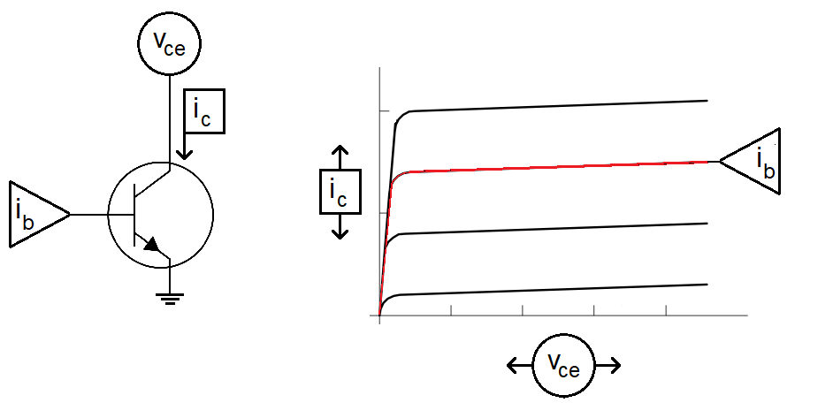

Figure 1: (Left) The signals needed to generate the characteristic family of curves for a BJT under test include ib, the base current, ic the collector current and vce the collector emitter voltage. (Right)

To generate the red curve in Figure 1 (right), we need to complete the following 3 plotting tasks:

1. Set the base current to the red value in Figure 1 (right) then,
2. Sweep the collector emitter voltage from 0V to 5V then while doing this,
3. Measure the collector current.

Fortunately, we have built most of the circuits needed to accomplish this in the previous labs. These circuits interface with the DUT and the current mirror shown in Figure 2 to generate the signals shown in Figure 1.

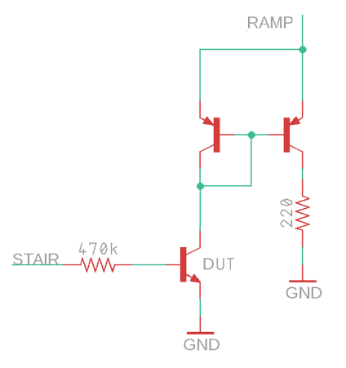

Figure 2: The output stage of the BJT curve tracer uses a current mirror to measure the collector current.

The list of plotting tasks is reframed in terms of the circuit shown in Figure 2 as:

1. The STAIR voltage is fed into the base of the DUT through a 470kΩ resistor, setting the base current.
2. The collector emitter voltage of the DUT sweeps from 0V to 5V using the output of the pseudo ramp generator.
3. The collector current of the DUT is indirectly measured, through the current mirror, as the voltage across a 220Ω resistor.

All that is needed now is a way to plot the collector emitter voltage against the collector current. This is where the X/Y mode of the oscilloscope comes into its own.

**Oscilloscope in X/Y Mode**

You have mainly used oscilloscopes in time-base mode, which means that the voltage on channel 1 is plotted vs. time. You can imagine that the voltage on channel 1 controls the height of the beam as the beam is being swept across the display. In X/Y mode, the oscilloscope uses the voltage on channel 1 to control the horizontal position (x-axis) of the beam and at the same time, uses the voltage on channel 2 to control the vertical position (y-axis) of the beam.

At first, this sounds really weird and counter-intuitive. However, you can do some pretty useful things with an oscilloscope in X/Y mode, like draw the family of curves for a BJT. To explore this idea further, let’s work the following example. Use the voltages on channel 1 and 2 in Figure 3 to determine what is displayed with the oscilloscope is X/Y mode. In this example:

* Ch 1 is configured to provide x-axis data,
* Ch 2 is configured to provide y-axis data,
* The vertical axis for Ch1 and Ch2 is 1 Volt per division,
* The center horizontal line is set to 0V.

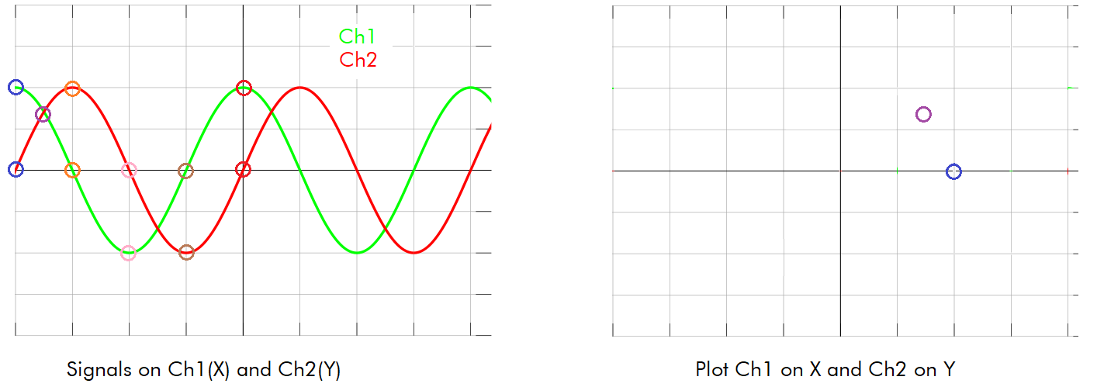

Figure 3: A pair of signals on Channel 1 and 2. Plot these 2 signals in XY mode.

At the left edge of the screen the values of Ch 1 and 2 are circled in blue, with Ch1=2V and Ch2=0V. So in the right half of Figure 3, a blue circle is placed at (x,y) = (2V, 0V). Note, the X/Y plot has the same scale as its respective channel.

Complete Table 1 by finding the voltages for channel 1 and 2 at the indicated times. Then place these points on the X/Y plot, connect the dots and determine what the user would see.The key to determining the scales of the X and Y axis in Error! Reference source not found. is the circuit which drives the X and Y signals, shown in Error! Reference source not found..

Table 1: The X,Y values of the curve in Figure 3.

|  |  |  |
| --- | --- | --- |
| Time | Ch 1 (X) | Ch 2 (Y) |
| Blue |  |  |
| Purple |  |  |
| Orange |  |  |
| Pink | -2 | 0 |
| Brown |  |  |
| Red |  |  |

**Axis Scale for BJT Curve Tracer**

We need a way to convert the picture shown on the oscilloscope into numerical data which informs us of the operation of the BJT. You will quantify the picture on the oscilloscope using the grid displayed on the oscilloscope screen and by the scale settings you establish by turing the Ch1 and Ch2 vertical scale knobs. Some notation is in order before we proceed:

* Let VSCALE_X be the volts per division you set with the Ch1 Vertical scale knob. This number is shown after the yellow “1” in the upper left corner of the oscilloscope screen.
* Let VSCALE_Y be the volts per division you set with the Ch2 Vertical scale knob. This number is shown after the green “2” in the upper left corner of the oscilloscope screen.
* Call the distance between the grid lines shown on the oscilloscope face, divisions.

For example, in Figure 4 VSCALE_X = 500mV/div and VSCALE_Y = 200mV/div. The X1 and X2 cursors are about 8.4 division apart.

* 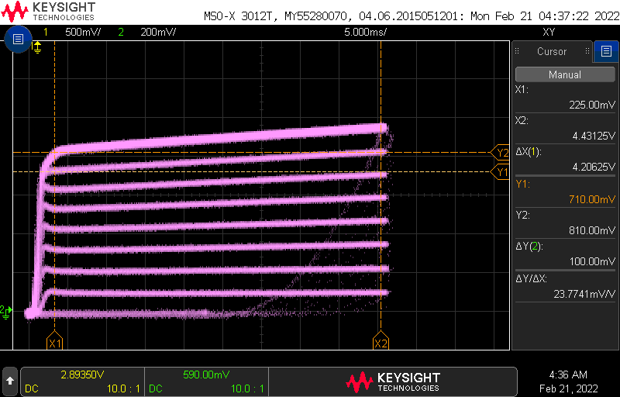

Figure 4: The oscilloscope showing the family of curves.

The key to finding an equation that allows us to convert the picture on the oscilloscope screen to numerical values are the circuits which drives the X and Y signals shown in Figure 5.

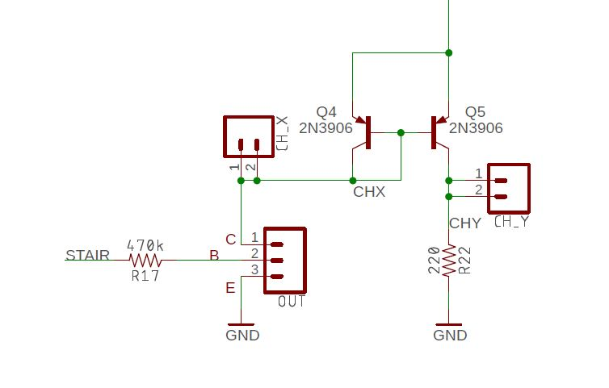

Figure 5: The circuit that generates the 2 channels for the X-Y mode.

Let’s start by examining the Horizontal scale.

**The Horizontal Axis Scale – Collector Emitter Voltage**

You will connect the Channel 1, CH_X in Figure 5, probe to the collector of the DUT, the scale of channel 1 is equal to the scale of the horizontal axis. This means that when you have Channel 1 scale set to 1V per division on the oscilloscope, the horizontal axis on the oscilloscope will show Vce at 1V per division. Thus, we have Equation 1:

|  |  |  |
| --- | --- | --- |
|  | Ch1 conversion factor | 1 |

In order to determine vce of a point on the oscilloscope screen, multiply it horizontal position (in divisions) by VSCALE_X and the Ch1 conversion factor. For example, if the voltage of a point is at X divisions, with the scope set to VSCALE_X = Y volts/div, then vce is given by Equation 2. Notice how the units cancel leading to the final answer in volts.

|  |  |  |
| --- | --- | --- |
|  |  | 2 |

I’ll agree that the discussion surrounding the Horizontal scale equation looks trivial. So, let’s explore the situation on Channel 2 where we will use these same concepts with more complex relationships.

**The Vertical Axis Scale – Collector Current**

You will connect the Channel 2, CH_Y in Figure 5, probe to the output of Q5 that is being run through a 220Ω resistor. Since Q4 and Q5 are arranged as a current mirror the current output of Q4 sets the current out of Q5. Since the current out of Q4 is the collector current, ic, of the DUT then the current output of Q5 is also equal to ic. Thus, the collector current is equal to the current flowing through the 220Ω resistor. The voltage at the CH_Y probe in Figure 5 is found using Ohm’s law and given by Equation 3.

|  |  |  |
| --- | --- | --- |
|  |  | 3 |

Solving Equation 3 for current over voltage leads us to the

|  |  |  |
| --- | --- | --- |
|  | Ch2 conversion factor | 4 |

In order to determine ic of a point on the oscilloscope screen, multiply it vertical position (in divisions) by VSCALE_Y and the Ch2 conversion factor. For example, if the current of a point is at X divisions, with the scope set to VSCALE_Y = Y volts/div, then ic is given by Equation 5. Notice how the units cancel leading to the final answer in volts.

|  |  |  |
| --- | --- | --- |
|  |  | 5 |

**Each Curve – Base Current**

As designed the circuit in Figure 5 keeps the DUT transistor in the active region. Thus the BE junction of the DUT has a 0.7V drop. Since the emitter of the DUT is grounded, this means that the base of the DUT is at 0.7V. Let’s call the voltage at the STAIR signal VSTAIR. You can use a combination of KVL and Ohm’s law to compute the voltage drop from VSTAIR to ground as

|  |  |  |
| --- | --- | --- |
|  |  | 6 |

Solving Equation 6 for ib yields Equation 7.

|  |  |  |
| --- | --- | --- |
|  |  | 7 |

# Computing the base current for each value of VSTAIR requires you to carefully measure the voltage of each step. Note, you can perform this measurement before you solder in the new components associated with this lab. To get these values, start by powering up your BJT curve tracer board with 9V from the lab power supplies. Next power up an oscilloscope, attach a probe to Channel 1 and configure the oscilloscope as follows:

|  |  |
| --- | --- |
| Ch1 probe | STAIR test point |
| Ch1 ground clip | GND test point |
| Horizontal (scale) | 1ms |
| Ch1 (scale) | 1V or 2V (whatever fits better) |
| Trigger mode | Auto |
| Trigger source | Ch1 |
| Trigger slope | ↓ |
| Trigger level | 4.5V |

# Now, measure the voltage of each step and record the values in the VSTAIR column of Table 2. Note that Trace 0 never leaves 0V. Trace 1 is the first trace above trace 0 and should be around 1v.

Table 2: The base current for each step of the staircase function created in Lab 3.

|  |  |  |
| --- | --- | --- |
| Trace | VSTAIR | ib (uA) |
| 9 |  |  |
| 8 |  |  |
| 7 |  |  |
| 6 |  |  |
| 5 |  |  |
| 4 |  |  |
| 3 |  |  |
| 2 |  |  |
| 1 |  |  |
| 0 |  |  |

Now, use the voltages in the VSTAIR column of Table 2 to compute the base current, ib, using Equation 7. You will need the information in Table 2 every time that your run the BJT curve tracer with a DUT. Let’s explore how we can use this information to calculate the gain and Early voltage of a DUT.

**Assemble the BJT Curve Tracer**

This week, you will be soldering in the components in the upper right corner of the BJT Curve Tracer PCB, completing the assembly as shown in Figure 6.

* You will need two 2N3906 PNP transistors to populate the Q5 and Q6 positions. Make sure the flat side of the PNP package aligns with the flat side of the PCB silkscreen.
* You will need one 2N3904 to populate the Q2 position in the ST Relax Oscillator area. Make sure the flat side of the PNP package aligns with the flat side of the PCB silkscreen.
* You will need to use the 3-pin header included in your parts bag for the DUT.
* Save the leads from your resistors to solder in the CH_X, XH_Y and GNG loops
* You do not need to install the bodged 10K resistor shown in Figure 6. This resistor goes between the lower terminal of R16 and the upper terminal of R6. It holds the Pseudo Ramp Generator at 0V during the FRAME pulse. I added this resistor to remove an annoying glitch on the oscilloscope characteristic curve created by the Pseudo Ramp output charging to 9V.

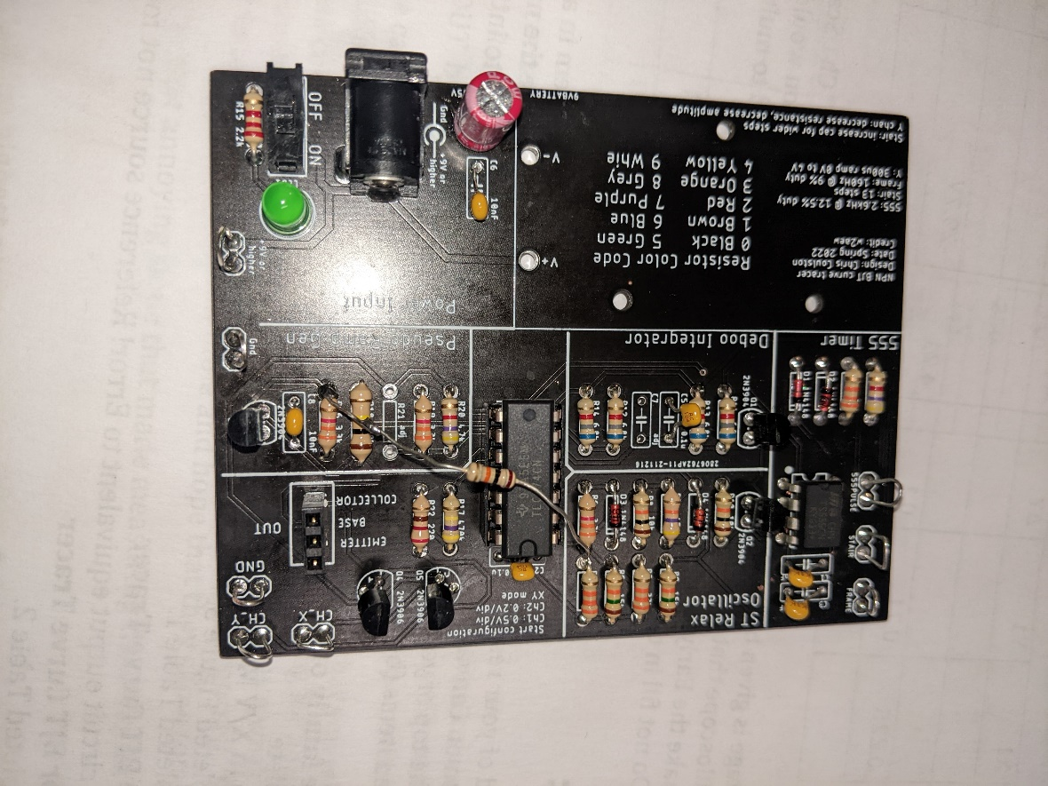

Figure 6: The completed BJT Curve Tracer board. Note the 10K resistor that’s bodged into the circuit is very optional.

Once you have completed soldering in the new components you will notice that the amplitude of the FRAME output will drop. The 555PUSE, STAIR and Pseudo Ramp outputs should be unchanged. Now it’s time to test your completed BJT Curve Tracer and get some data from it.

**Inserting the DUT into the BJT Curve Tracer**

You will be measuring the performance of several BJTs or this week’s lab. In order to do this you will have to insert the leads of the BJT into the correct socket positions shown in Figure 7C. I orientated the DUT socket with the 2N3904 and 2N2222 BJTs in mind. To see how that effected the design, look closely at the arrangement of pins in Figure 7A and B. Even though the pins are arranged differently, the base is the center pin.

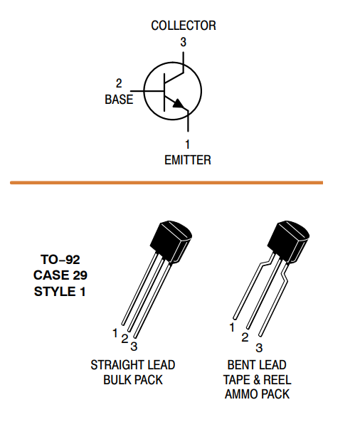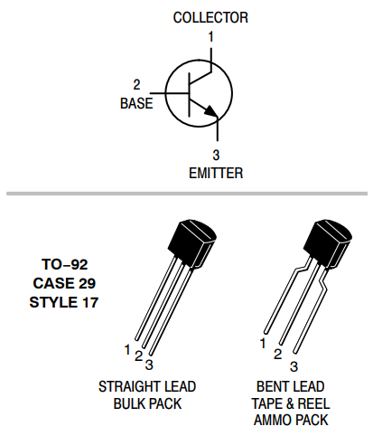 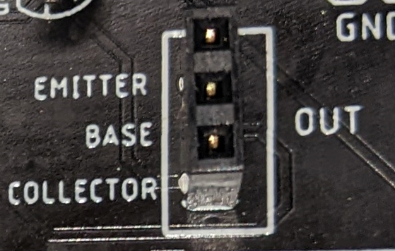

1. (B) (C)

Figure : (A) The datasheet for the 2N3904. (B) The datasheet for the 2N2222. (C) The socket for the DUT – yes that is a typo on the silk screen.

So you have to insert the 2N3904 into the DUT socket so that the BJTs flat side is facing left. While you have to insert the 2N2222 into the DUT socket so that the BJTs flat side is facing right. You will not harm the test BJT if you put it in backwards.

The BJTs shown in Figure 7A and B are encased in JEDEC standardard Transistor Outline Package, Case Style 92 or TO-92 package. It seems that most BJTs in a TO-92 package have the base as their center pin. This makes inserting them into the DUT socket a matter of trying two different orientations. The situation gets more complex for larger packages.

Before we continue, a note about BJT datasheets. Often BJTs are developed in complementary NPN/PNP pairs. We see this with the Motorola designed 2N3904 and 2N3906 BJTs. Being designed as complementary pairs, the manufactures often group the two complementary BJTs on the same datasheet for efficiency. When the manufacture does this, you need to look for the NPN device because that is the one you will be testing in the BJT Curve Tracer.

Now, look at the datasheet for the BD139 and TIP41C shown in Figure 8A and B.

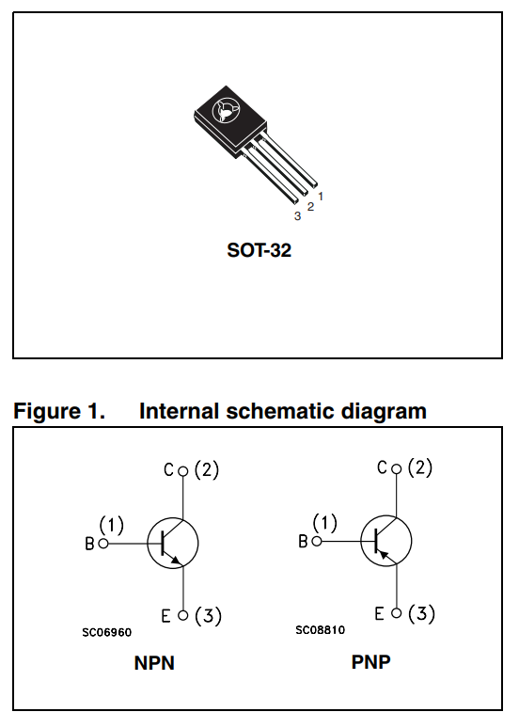 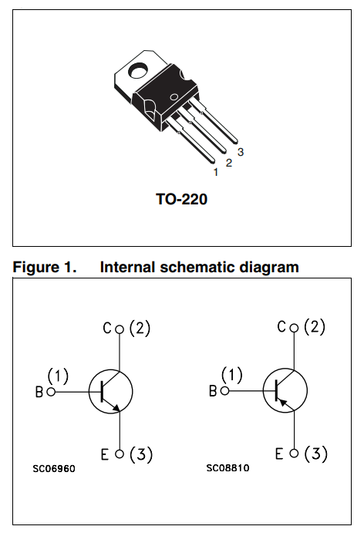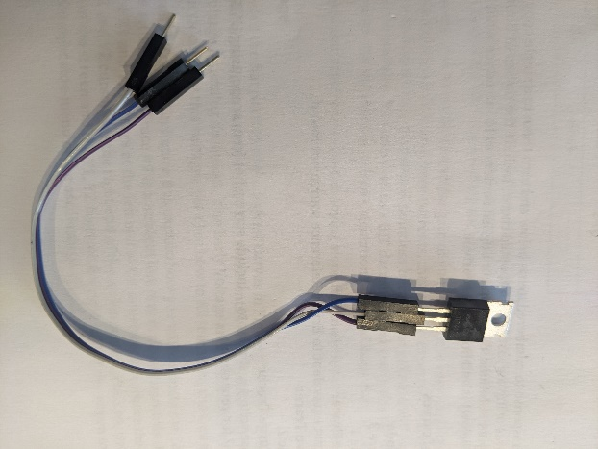

Figure 8: (A) The pinout for the BD139 (NPN) and BD140 (PNP). The pinout of the TIP41C (NPN) and TIP42C (PNP). You can use a set of jumper wires to adapt the pins of non-conforming devices to the DUT socket.

In Figure 8A the NPN device is called out as “NPN”. You can see that the base of the BD139 is on the right side of the package when viewed from the front. In Figure 8B the NPN device is called out using its schematic symbol. You should see that the base is on the left side of the package when viewed from the front.

In both cases you will need to reposition the BJTs package leads before connecting it to the DUT socket. Do not bend the leads to accomplish this. Doing so, you risk breaking the leads, shorting the leads together and it makes you look like a hack - a bad look. Instead, connect 3 male/female jumper wires as shown in Figure 8C to the BJT and then connect the male ends of the leads to the DUT socket.

**Completing the BJT Performance Card the BJT**

By completing the BJT performance card, you will be able to determine two important parameters of the BJT under test, the DC gain and the Early voltage. To determine these parameters, download and open the bjtPerformanceCard word document posted on Canvas. The document should look similar to Figure 9. Use the information from Table 2 to fill in the ib column in the table circled in red in Figure 9. While you are at it, fill in your name in the Name field and the identity of the BJT in the Device ID field. Since your BJT curve tracer is unique to you and the information in Table 2 will not change, you might as well save a personal copy of the bjtPerformanceCard document with this information typed in permanently.

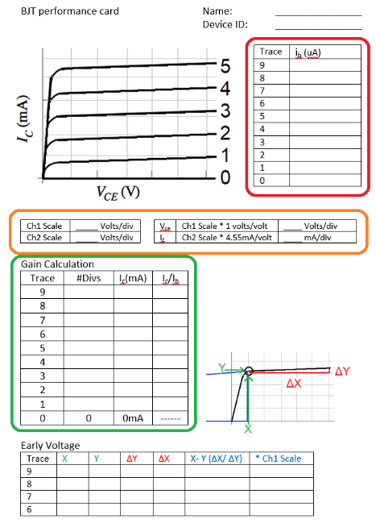

Figure 9: The BJT Performance card that you will fill out for every DUT. Text will be colored red, orange, or green when it describes how to fill in the BJT Performance Card table circled in that color.

By filling in this information you have taken the first step in computing the Gain Calculation table outlined in green. Let’s see what other information you need to collect and compute in order to complete the Gain Calculation table.

Start by powering the BJT Curve Tracer with 9V from a lab power supply. Next connect the oscilloscope these as shown in <Figure ref>. Finally, insert a test BJT into the DUT socket.

Next you will need to setup your oscilloscope as shown in the following table. Note that you may need to make adjustments to this configuration depending on the DUT.

|  |  |
| --- | --- |
| Horizontal (scale) | 5ms |
| Ch1 probe | CH_X |
| Ch1 (scale) | 0.5V/div |
| Ch 1(position) | Lowest visible reticule |
| Ch2 probe | CH_Y |
| Ch2 (scale) | 0.2V/div |
| Ch 2(position) | Lowest visible reticule |
| Trigger mode | Auto |

You should see a pretty chaotic set of waveforms like that shown in Figure 10 with activity on both channels. If either channel has no signal, make sure that the DUT is firmly inserted into the test fixture or that you have the DUT inserted backwards (some BJTs have the collector and emitter terminals swapped). Adjust the ground reference of both channels to the lowest visible reticule.

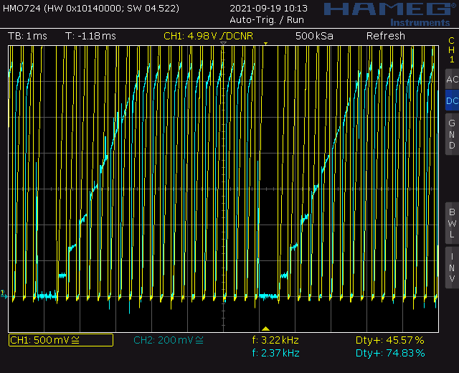

Figure 10: The oscilloscope output with a DUT in normal model

Next you will need to put the oscilloscope into X/Y mode. Find the **Horiz** button and then use the softkey menu to select X/Y.

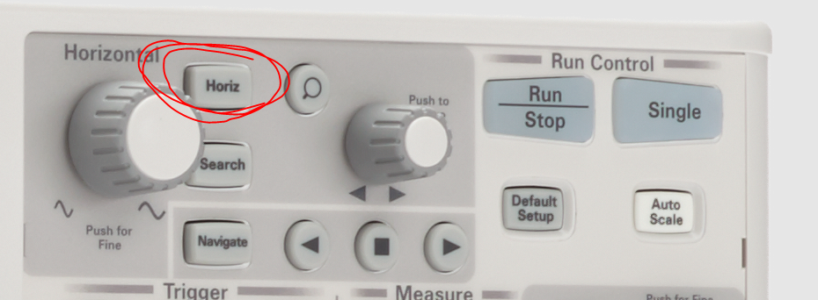

You should see something similar to Figure 11. You may adjust the Ch1 and Ch2 scale to make the family of curves fill the occupied space on the screen. Adjust the Ch1 and Ch2 offset so that the lower left corner of the family of curves is at the intersection of the lowest left visible reticule. I will refer to the lower left corner of the family of curves as the **origin**.



Figure 11: The BJT family of curves for the DUT. I’ve been told that hitting the Run/Stop button on the oscilloscope can help improve the image quality.

# Congratulations, you have your BJT curve tracer working! Let’s figure out how to get numerical information from the plot to complete the Gain Calculation portion to the BJT Performance Card.

**Gain Calculation**

The following text will be color coded red, orange or green when it refers to one of the circled areas in Figure 9. The data in this section will be a combination of the information contained in Figure 11 and the base currents found in Table 2. Your values will be different.

Fill in the orange circled area of Figure 9 with the scale you set on your oscilloscope. For example, in Figure 11 you should fill in 0.5V for the Ch1 Scale and 0.2V for the Ch2 scale. Next multiply the scale values from your oscilloscope by the respective constants to get the volts/div or mA/div. For example in Figure 11 you should fill in 0.5 Volts/div for the Ch1 and 0.9mA/div for the Ch2.

Now you need to fill in the green circled area to determine the collector current for each of the curves. You will do this by estimating the height of each curve and fill in this information in the #Divs column. It should be clear by looking at Figure 11 that the curves are not perfectly horizontal, they slope upwards. This makes it difficult to determine where to measure the height of the curve, so here is a heuristic. Measure the height of the curve at Vce = 1V (2 division to the right of the origin in Figure 11) in divisions.

Table : The Gain Calculation table filled in using the information from Figure 11. These gains have very good agreement. Do not be concerned if your values exhibit more variation.

|  |  |  |  |
| --- | --- | --- | --- |
| Trace | #Divs | ic | ic/ib |
| 9 | 4.3 | 3.9 | 250 |
| 8 | 4.2 | 3.8 | 250 |
| 7 | 3.6 | 3.2 | 241 |
| 6 | 3.2 | 2.9 | 254 |
| 5 | 2.7 | 2.4 | 258 |
| 4 | 2.1 | 1.9 | 257 |
| 3 | 1.5 | 1.4 | 255 |
| 2 | 1.1 | 1.0 | 278 |
| 1 | 0.4 | 0.36 | 240 |
| 0 | 0 | 0mA | -------- |

Next fill in the collector current column, ic, by multiplying the value in the #Divs column by the Ch2 value (using Equation 5). Round your answers to 2 significant figures. Finally fill out the ic/ib column, the gain of the DUT, by dividing each traces collector current by its associated base current.

Congratulations, you have calculated the gain of your DUT! It is very likely that you will get different gain values for different base currents, this is to be expected. Asking for a single value of gain across a variety of base currents is pointless because the gain of a BJT has a weak dependence on the collector current. You can look in a BJT datasheet and verify this for yourself. So we have to be satisfied with the values in our Gain Calculation table and hope that they show some agreement.

Now, let’s turn our attention to that annoying slope that made measuring the collector current difficult.

**Early Voltage**

If you extended the flat portion of the highest curves in Figure 11 to the left, the line would interest the horizontal axis. Since the horizontal axis represents voltage, this intercept is a voltage, called the Early Voltage by analog designers. The Early Voltage area of the BJT Performance Card will assist you in calculating this voltage. Let’s see how to fill it in using the data in Figure 11.

We will examine Trace #7 in Figure 11 to explain how you will compute the Early voltage for your DUT. In the active region, Trace #7 is a straight line that is sloped upwards. Use the cursor function and align the X1 and Y1 cursors at the left end of the active region, where the curve is flat. Next align the X2 and Y2 cursors on the right end of the active region. You can use the X1 and X2 flags at the bottom of the screen and the Y1, Y2 flags on the right side of the screen to interpret the values shown on the right side-menu of the oscilloscope display.

Table 4: The Ealy Voltage table partially filled in using the data from Figure 11.

|  |  |  |  |  |  |  |
| --- | --- | --- | --- | --- | --- | --- |
| Trace | X1 | Y1 | ΔY | ΔX | X-Y(ΔX/ ΔY) | *Ch1 Scale |
| 9 |  |  |  |  |  |  |
| 8 |  |  |  |  |  |  |
| 7 | 0.225 | 0.71 | 0.1 | 4.21 | -29.7V | -------------- |
| 6 |  |  |  |  |  |  |

The Early Voltage is given by the value in the X-Y(ΔX/ ΔY) column. The “*Ch1 Scale” column is useful for oscilloscope that do not have a cursor function. In this case, you would need to count divisions to make the Early Voltage computation and consequently need to multiply by the Ch1 scale factor. Do not fill in this column if you use the cursor function.

# Turn in:

Make a record of your response to numbered items below and turn them in to Canvas using the instructions posted there. While you can work together to answer the questions in this lab document, you will work individually, with your own BJT Curve Tracer board, to test 3 BJTs. Thus, everyone is expected to turn in their own document. If you worked with someone, please include their name at the top of your document.

**Oscilloscope in X/Y Mode**

Completed Figure 3.

Completed Table 1.

**Axis Scale for BJT Curve Tracer**

Completed Table 2.

**Completing the BJT Performance Card the BJT**

Complete a BJT Performance Card for the 2N3904 or 2N2222 BJT.

Complete a BJT Performance Card for the BD139 or TIP41C BJT.

Complete a BJT Performance Card for some other NPN BJT you find in the lab. As a first step, find the device datasheet. From this:

* + Find the pinout – Base, Emitter, Collector
  + Find the DC gain at the collector current around the values in Table 3.
  + Compare your calculated gain to the datasheet gain and note this somewhere on the BJT Performance Card.